# [Fundamentals of Azure OpenAI Service](https://learn.microsoft.com/en-us/training/modules/explore-azure-openai/) – training

Get to know the connection between artificial intelligence (AI), Responsible AI, and text, code, and image generation. Understand how you can use Azure OpenAI to build solutions against AI models within Azure.

**Learning objectives**

In this module you'll learn how to:

* Describe Azure OpenAI workloads and access the Azure OpenAI Service
* Understand generative AI models
* Understand Azure OpenAI's language, code, and image capabilities
* Understand Azure OpenAI's responsible AI practices and limited access policies

## This module is part of these learning paths - [Microsoft Azure AI Fundamentals: Generative AI](https://learn.microsoft.com/training/paths/introduction-generative-ai/)

* [Introduction](https://learn.microsoft.com/en-us/training/modules/explore-azure-openai/1-introduction)3 min
* [What is generative AI](https://learn.microsoft.com/en-us/training/modules/explore-azure-openai/2-what-is-generative-ai)3 min
* [Describe Azure OpenAI](https://learn.microsoft.com/en-us/training/modules/explore-azure-openai/3-describe-azure-openai)5 min
* [How to use Azure OpenAI](https://learn.microsoft.com/en-us/training/modules/explore-azure-openai/4-how-to-use-azure-openai)3 min
* [Understand OpenAI's natural language capabilities](https://learn.microsoft.com/en-us/training/modules/explore-azure-openai/5-understand-openai-natural-language)5 min
* [Understand OpenAI code generation capabilities](https://learn.microsoft.com/en-us/training/modules/explore-azure-openai/6-understand-openai-code-generation)6 min
* [Understand OpenAI's image generation capabilities](https://learn.microsoft.com/en-us/training/modules/explore-azure-openai/7-understand-openai-image-generation)5 min
* [Describe Azure OpenAI's access and responsible AI policies](https://learn.microsoft.com/en-us/training/modules/explore-azure-openai/8-describe-openai-responsible-ai)3 min
* [Exercise - Explore Azure OpenAI Service](https://learn.microsoft.com/en-us/training/modules/explore-azure-openai/8a-exercise-openai)25 min
* [Knowledge check](https://learn.microsoft.com/en-us/training/modules/explore-azure-openai/9-knowledge-check)4 min
* [Summary](https://learn.microsoft.com/en-us/training/modules/explore-azure-openai/10-summary)1 min

1. [als: Generative AI](https://learn.microsoft.com/en-us/training/paths/introduction-generative-ai/)

1. [Fundamentals of Azure OpenAI Service](https://learn.microsoft.com/en-us/training/modules/explore-azure-openai/)

Add

* Unit 1 of 11

[**Next**](https://learn.microsoft.com/en-us/training/modules/explore-azure-openai/2-what-is-generative-ai/)

# Introduction

Completed100 XP

* 3 minutes

Suppose you want to help your team understand the latest artificial intelligence (AI) innovations in the news. Your team would like to evaluate the opportunities these innovations support and understand what is done to keep AI advancements ethical.

You share with your team that today, stable AI models are regularly put into production and used commercially around the world. For example, Microsoft's existing Azure AI services have been handling the needs of businesses for many years to date. In 2022, OpenAI, an AI research company, created a chatbot known as ChatGPT and an image generation application known as DALL-E. These technologies were built with AI models which can take natural language input from a user and return a machine-created human-like response.

You share with your team that Azure OpenAI Service enables users to build enterprise-grade solutions with OpenAI models. With Azure OpenAI, users can summarize text, get code suggestions, generate images for a web site, and much more. This module dives into these capabilities.

## Capabilities of OpenAI AI models

There are several categories of capabilities found in OpenAI AI models, three of these include:

Expand table

| **Capability** | **Examples** |
| --- | --- |
| Generating natural language | Such as: summarizing complex text for different reading levels, suggesting alternative wording for sentences, and much more |
| Generating code | Such as: translating code from one programming language into another, identifying and troubleshooting bugs in code, and much more |
| Generating images | Such as: generating images for publications from text descriptions and much more |

## Next unit: What is generative AI

OpenAI makes its AI models available to developers to build powerful software applications, such as ChatGPT. There are tons of [other examples of OpenAI](https://platform.openai.com/examples) applications on the OpenAI site, ranging from practical, such as generating text from code, to purely entertaining, such as making up scary stories.

Let's identify where OpenAI models fit into the AI landscape.

* **Artificial Intelligence** imitates human behavior by relying on machines to learn and execute tasks without explicit directions on what to output.
* **Machine learning** algorithms take in data like weather conditions and fit models to the data, to make predictions like how much money a store might make in a given day.
* **Deep learning** models use layers of algorithms in the form of artificial neural networks to return results for more complex use cases. Many Azure AI services are built on deep learning models. You can check out this article to learn more about the [difference between machine learning and deep learning.](https://learn.microsoft.com/en-us/azure/machine-learning/concept-deep-learning-vs-machine-learning)
* **Generative AI** models can produce new content based on what is described in the input. The OpenAI models are a collection of generative AI models that can produce language, code, and images.

Next you'll learn how Azure OpenAI gives users the ability to combine Azure's enterprise-grade solutions with many of OpenAI's same generative AI models.

## Unit-3: Describe Azure OpenAI

Microsoft has partnered with OpenAI to deliver on three main goals:

* To utilize Azure's infrastructure, including security, compliance, and regional availability, to help users build enterprise-grade applications.
* To deploy OpenAI AI model capabilities across Microsoft products, including and beyond Azure AI products.
* To use Azure to power all of OpenAI's workloads.

## Introduction to Azure OpenAI Service

Azure OpenAI Service is a result of the partnership between Microsoft and OpenAI. The service combines Azure's enterprise-grade capabilities with OpenAI's generative AI model capabilities.

Azure OpenAI is available for Azure users and consists of four components:

* Pre-trained generative AI models
* Customization capabilities; the ability to fine-tune AI models with your own data
* Built-in tools to detect and mitigate harmful use cases so users can implement AI responsibly
* Enterprise-grade security with role-based access control (RBAC) and private networks

Using Azure OpenAI allows you to transition between your work with Azure services and OpenAI, while utilizing Azure's private networking, regional availability, and responsible AI content filtering.

### Understand Azure OpenAI workloads

Azure OpenAI supports many common AI workloads and solves for some new ones.

Common AI workloads include machine learning, computer vision, natural language processing, conversational AI, anomaly detection, and knowledge mining.

Other AI workloads Azure OpenAI supports can be categorized by tasks they support:

* **Generating Natural Language**
  + Text completion: generate and edit text
  + Embeddings: search, classify, and compare text
* **Generating Code**: generate, edit, and explain code
* **Generating Images**: generate and edit images

### Azure OpenAI's relationship to Azure AI services

**Note**

As of July 2023, Azure AI services encompass all of what were previously known as Cognitive Services and Azure Applied AI Services.

Azure AI services are tools for solving AI workloads. The services you choose to use depend on what you need to accomplish. In particular, there are several overlapping capabilities between Azure AI Language service and Azure OpenAI Service, such as translation, sentiment analysis, and keyword extraction.

While there's no strict guidance on when to use a particular service, Azure AI Language service can be used for widely known use-cases that require minimal tuning (the process of optimizing a model's performance). Azure OpenAI Service may be more beneficial for use-cases that require highly customized generative models, or for exploratory research.

**Note**

Pricing is different for Azure OpenAI and Azure AI Language service. [**Learn more here**](https://azure.microsoft.com/pricing/details/cognitive-services/openai-service).

When making business decisions about what type of model to use, it's important to understand how time and compute needs factor into machine learning training. In order to produce an effective machine learning model, the model needs to be trained with a substantial amount of cleaned data. The 'learning' portion of training requires a computer to identify an algorithm that best fits the data. The complexity of the task the model needs to solve for and the desired level of model performance all factor into the time required to run through possible solutions for a best fit algorithm.

## Unit-4: How to use Azure OpenAI

Currently you need to [apply](https://aka.ms/oaiapply) for access to Azure OpenAI. Once granted access, you can use the service by creating an Azure OpenAI resource, like you would for other Azure services. Once the resource is created, you can use the service through REST APIs, Python SDK, or the web-based interface in the Azure OpenAI Studio.

**Note**

To learn more about the basics of APIs, check out this infographic on [**how Azure APIs work**](https://github.com/MicrosoftLearning/AI-900-AIFundamentals/raw/main/instructions/infographics/ai900_how_auzre_api_works.pdf).

## Azure OpenAI Studio

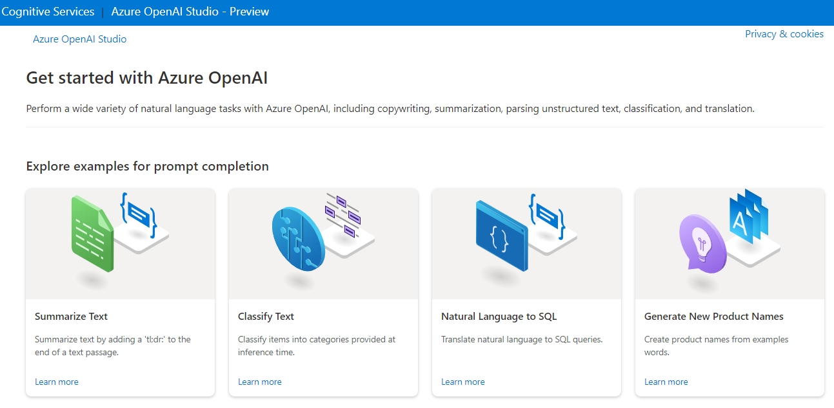

In the [Azure OpenAI Studio](https://oai.azure.com/portal), you can build AI models and deploy them for public consumption in software applications. Azure OpenAI's capabilities are made possible by specific generative AI models. Different models are optimized for different tasks; some models excel at summarization and providing general unstructured responses, and others are built to generate code or unique images from text input.

These Azure OpenAI models include:

* **GPT-4** models that represent the latest generative models for natural language and code.
* **GPT-3.5** models that can generate natural language and code responses based on prompts.
* **Embeddings** models that convert text to numeric vectors for analysis - for example comparing sources of text for similarity.
* **DALL-E** models that generate images based on natural language descriptions.

Azure OpenAI's AI models can all be trained and customized with fine-tuning. We won't go into custom models here, but you can learn more on the [fine-tuning your model](https://learn.microsoft.com/en-us/azure/ai-services/openai/how-to/fine-tuning?pivots=programming-language-studio%3Fazure-portal%3Dtrue) Azure documentation.

**Important**

Generative AI models always have a probability of reflecting true values. Higher performing models, such as models that have been fine-tuned for specific tasks, do a better job of returning responses that reflect true values. It is important to review the output of generative AI models.

#### Playgrounds

In the Azure OpenAI Studio, you can experiment with OpenAI models in playgrounds. In the Completions playground, you can type in prompts, configure parameters, and see responses without having to code.

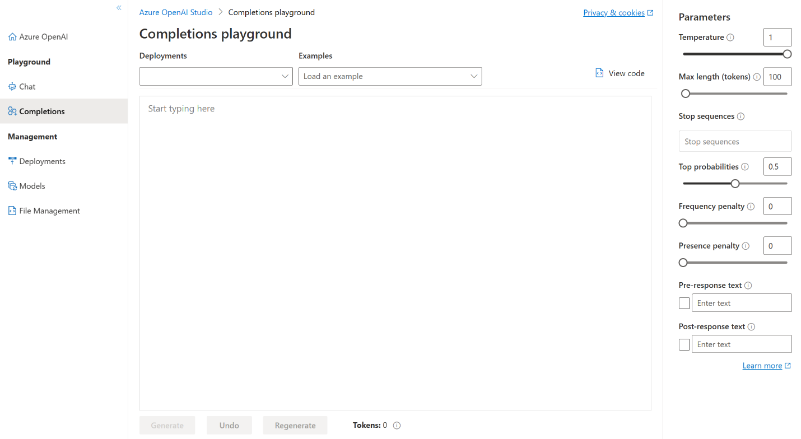

In the Chat playground, you can use the assistant setup to instruct the model about how it should behave. The assistant will try to mimic the responses you include in tone, rules, and format you've defined in your system message.

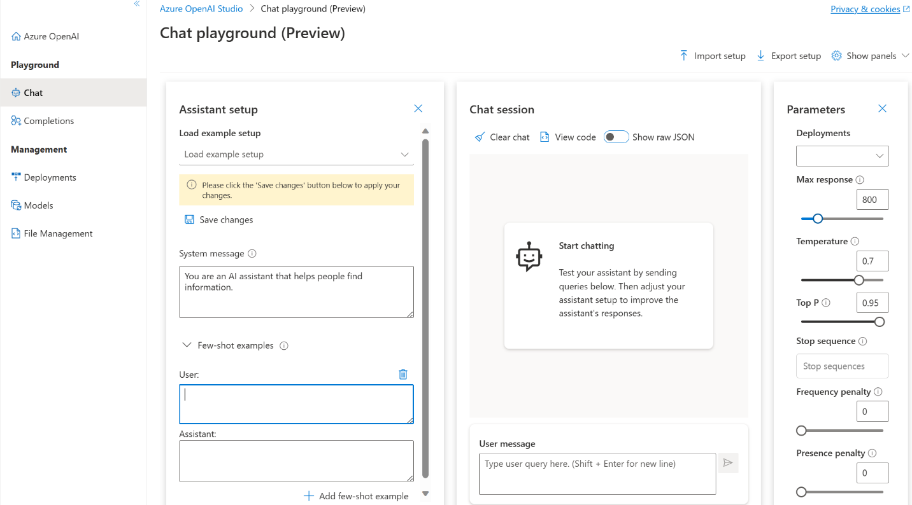

## Unit5: Understand OpenAI's natural language capabilities

Azure OpenAI's natural language models are able to take in natural language and generate responses.

Natural language learning models are trained on words or chunks of characters known as tokens. For example, the word "hamburger" gets broken up into the tokens ham, bur, and ger, while a short and common word like "pear" is a single token. These tokens are mapped into vectors for a machine learning model to use for training. When a trained natural language model takes in a user's input, it also breaks down the input into tokens.

## Understanding GPT models for natural language generation

Generative pre-trained transformer (GPT) models are excellent at both understanding and creating natural language. If you've seen recent news around AI answering questions or writing a paragraph based on a prompt, it likely could have been generated by a GPT model such as GPT-35-Turbo or GPT-4.

#### What does a response from a GPT model look like?

A key aspect of OpenAI's generative AI is that it takes an input, or **prompt**, to return a natural language, visual, or code response. GPT tries to infer, or guess, the context of the user's question based on the prompt.

GPT models are great at completing several natural language tasks, some of which include:

Expand table

| **Task** | **Prompt** |
| --- | --- |
| Summarizing text | "Summarize this text into a short blurb" |
| Classifying text | "What genre of book is this?" |
| Generating names or phrases | "Write a tagline for my flower company" |
| Translation | "Translate 'How are you' to French" |
| Answering questions | "What does Azure OpenAI do?" |
| Suggesting content | "Give me the five best weddings songs" |

For example, given a prompt where the user types in text asking for a cooking recipe:

Copy

Write a recipe based on these ingredients and instructions:

Fruit Pie

Ingredients:

Strawberries

Blueberries

Flour

Eggs

Milk

Here's an example of the OpenAI API generated response:

Copy

Instructions:

1. Preheat your oven to 350 degrees Fahrenheit.

2. In a medium bowl, mix together 1 cup of flour and 1 egg until it forms a dough.

3. Grease a 9-inch pie dish with butter or non-stick cooking spray.

4. Roll out the dough and place it in the pie dish.

5. In a separate bowl, mix together 1 cup of strawberries, 1 cup of blueberries, and 1 cup of milk.

6. Pour the fruit mixture into the pie dish.

7. Bake

Delicious - maybe! It's important to understand that the generated responses are best guesses from a machine. In this case, the generated text may be useful for cooking something that tastes good in real life, or not.

## How models are applied to new use cases

You may have tried out ChatGPT's predictive capabilities in a chat portal, where you can type prompts and receive automated responses. The portal consists of the front-end user interface (UI) users see, and a back-end that includes a generative AI model. The combination of the front and back end can be described as a chatbot. The model provided on the back end is what is available as a building block with both the OpenAI API and Azure OpenAI API. You can utilize ChatGPT's capabilities on Azure OpenAI via the GPT-35-turbo model. When you see generative AI capabilities in other applications, developers have taken the building blocks, customized them to a use case, and built them into the back end of new front-end user interfaces.

## Unit-6: Understand OpenAI code generation capabilities

GPT models are able to take natural language or code snippets and translate them into code. The OpenAI GPT models are proficient in over a dozen languages, such as C#, JavaScript, Perl, PHP, and is most capable in Python.

GPT models have been trained on both natural language and billions of lines of code from public repositories. The models are able to generate code from natural language instructions such as code comments, and can suggest ways to complete code functions.

For example, given the prompt "Write a for loop counting from 1 to 10 in Python," the following answer is provided:

PythonCopy

for i in range(1,11):

print(i)

GPT models can help developers code faster, understand new coding languages, and focus on solving bigger problems in their application. Developers can break down their goals into simpler tasks and use GPT to help build out those tasks using known patterns.

## Examples of code generation

Part of the training data for GPT-3 included programming languages, so it's no surprise that GPT models can answer programming questions if asked. What's unique about the Codex model family is that it's more capable across more languages than GPT models.

Code generation goes beyond just writing code from natural language prompts. Given the following code, it can generate unit tests:

PythonCopy

# Python 3

def mult_numbers(a, b):

return a * b

# Unit test

def

GPT builds out unit tests for our function:

PythonCopy

# Python 3

def mult_numbers(a, b):

return a * b

# Unit test

def test_mult_numbers():

assert mult_numbers(3, 4) == 12

assert mult_numbers(0, 10) == 0

assert mult_numbers(4, 0) == 0

# Unit test

def test_mult_numbers_negative():

assert mult_numbers(-1, 10) == -10

assert mult_numbers(10, -1) == -10

GPT can also summarize functions that are already written, explain SQL queries or tables, and convert a function from one programming language into another.

When interacting with GPT models, you can specify libraries or language specific tags to make it clear to Codex what we want. For example, we can provide this prompt formatted as an HTML comment: <!-- build a page titled "Let's Learn about AI" -->, and get this as a result:

HTMLCopy

<html>

<head>

<title>Let's Learn about AI</title>

<link rel="stylesheet" type="text/css" href="css/styles.css">

</head>

<body>

<div class="wrapper">

<div class="header">

<h1>Let's Learn about AI</h1>

</div>

<div class="nav">

<ul>

<li><a href="index.php">Home</a></li>

<li><a href="about.php">About</a></li>

<li><a href="resources.php">Resources</a></li>

<li><a href="contact.php">Contact</a></li>

</ul>

</div>

<div class="content">

<h2>Contact</h2>

<p>

<!-- build a form to contact the site owner -->

<form action="contact.php" method="post">

<label for="name">Name:</label>

<input type="text" name="name" id="name" required>

<label for="email">Email:</label>

<input type="email" name="email" id="email" required>

<label for="subject">Subject:</label>

<input type="text" name="subject" id="subject" required>

<label for="message">Message:</label>

<textarea name="message" id="message" required></textarea>

<input type="submit" value="Send">

</form>

</p>

</div>

<div class="footer">

<p>Let's Learn about AI</p>

</div>

</div>

</body>

</html>

## GitHub Copilot

OpenAI partnered with GitHub to create GitHub Copilot, which they call an AI pair programmer. GitHub Copilot integrates the power of OpenAI Codex into a plugin for developer environments like Visual Studio Code.

Once the plugin is installed and enabled, you can start writing your code, and GitHub Copilot starts automatically suggesting the remainder of the function based on code comments or the function name. For example, we have only a function name in the file, and the gray text is automatically suggested to complete it.

GitHub Copilot offers multiple suggestions for code completion, which you can tab through using keyboard shortcuts. When given informative code comments, it can even suggest a function name along with the complete function code.

## Unit7: Understand OpenAI's image generation capabilities

Image generation models can take a prompt, a base image, or both, and create something new. These generative AI models can create both realistic and artistic images, change the layout or style of an image, and create variations on a provided image.

## DALL-E

In addition to natural language capabilities, generative AI models can edit and create images. The model that works with images is called DALL-E. Much like GPT models, subsequent versions of DALL-E are appended onto the name, such as DALL-E 2. Image capabilities generally fall into the three categories of image creation, editing an image, and creating variations of an image.

## Image generation

Original images can be generated by providing a text prompt of what you would like the image to be of. The more detailed the prompt, the more likely the model will provide a desired result.

With DALL-E, you can even request an image in a particular style, such as "a dog in the style of Vincent van Gogh". Styles can be used for edits and variations as well.

For example, given the prompt "an elephant standing with a burger on top, style digital art", the model generates digital art images depicting exactly what is asked for.



When asked for something more generic like "a pink fox", the images generated are more varied and simpler while still fulfilling what is asked for.



However when we make the prompt more specific, such as "a pink fox running through a field, in the style of Monet", the model creates much more similar detailed images.



## Editing an image

When provided an image, DALL-E can edit the image as requested by changing its style, adding or removing items, or generating new content to add. Edits are made by uploading the original image and specifying a transparent mask that indicates what area of the image to edit. Along with the image and mask, a prompt indicating what is to be edited instructs the model to then generate the appropriate content to fill the area.

When given one of the above images of a pink fox, a mask covering the fox, and the prompt of "blue gorilla reading a book in a field", the model creates edits of the image based on the provided input.

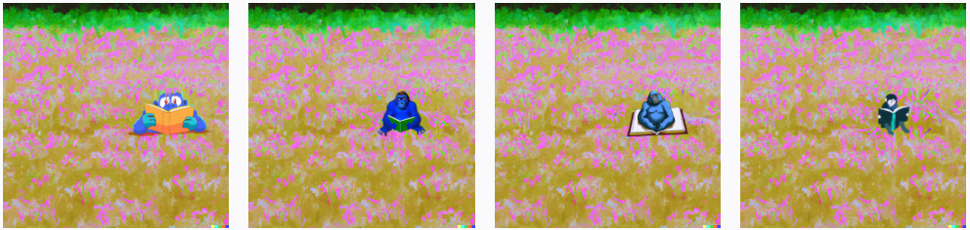

## Image variations

Image variations can be created by providing an image and specifying how many variations of the image you would like. The general content of the image will stay the same, but aspects will be adjusted such as where subjects are located or looking, background scene, and colors may change.

For example, if I upload one of the images of the elephant wearing a burger as a hat, I get variations of the same subject.



**Note**

Access to DALL-E is currently granted on an invite basis only.

## Unit8: Describe Azure OpenAI's access and responsible AI policies

It's important to consider the ethical implications of working with AI systems. Azure OpenAI provides powerful natural language models capable of completing various tasks and operating in several different use cases, each with their own considerations for safe and fair use. Teams or individuals tasked with developing and deploying AI systems should work to identify, measure, and mitigate harm.

Usage of Azure OpenAI should follow the six Microsoft [AI principles](https://learn.microsoft.com/en-us/azure/machine-learning/concept-responsible-ai):

* **Fairness**: AI systems shouldn't make decisions that discriminate against or support bias of a group or individual.
* **Reliability and Safety**: AI systems should respond safely to new situations and potential manipulation.
* **Privacy and Security**: AI systems should be secure and respect data privacy.
* **Inclusiveness**: AI systems should empower everyone and engage people.
* **Accountability**: People must be accountable for how AI systems operate.
* **Transparency**: AI systems should have explanations so users can understand how they're built and used.

Responsible AI principles guide [Microsoft's Transparency Notes on Azure OpenAI](https://learn.microsoft.com/en-us/legal/cognitive-services/openai/transparency-note), as well as explanations of other products. Transparency Notes are intended to help you understand how Microsoft's AI technology works, the choices system owners can make that influence system performance and behavior, and the importance of thinking about the whole system, including the technology, the people, and the environment.

If you haven't completed the [Get started with AI on Azure](https://learn.microsoft.com/en-us/training/modules/get-started-ai-fundamentals) module, it's worth reviewing its unit on [responsible AI](https://learn.microsoft.com/en-us/training/modules/get-started-ai-fundamentals/8-understand-responsible-ai).

## Limited access to Azure OpenAI

As part of Microsoft's commitment to using AI responsibly, access to Azure OpenAI is currently limited. Customers that wish to use Azure OpenAI must submit a registration form for both initial experimentation access, and again for approval for use in production.

Additional registration is required for customers who want to modify content filters or modify abuse monitoring settings.

To apply for access and learn more about the limited access policy, see the [Azure OpenAI limited access](https://learn.microsoft.com/en-us/legal/cognitive-services/openai/limited-access) documentation.

## Unit9: Exercise - Explore Azure OpenAI Service

# [**Explore Azure OpenAI**](https://microsoftlearning.github.io/mslearn-ai-fundamentals/Instructions/Labs/13-azure-openai.html)

## Unit10: Knowledge check

# Knowledge check

200 XP

* 4 minutes

Top of Form

**1.**

**How are ChatGPT, OpenAI, and Azure OpenAI related?**

Azure OpenAI is Microsoft's version of ChatGPT, a chatbot that uses generative AI models.

ChatGPT and OpenAI are chatbots that generate natural language, code, and images. Azure OpenAI provides access to these two chatbots.

OpenAI is a research company that developed ChatGPT, a chatbot that uses generative AI models. Azure OpenAI provides access to many of OpenAI's AI models.

**2.**

**You would like to summarize a paragraph of text. Which generative AI model family would you use to solve for this workload?**

GPT.

Codex.

Dall-E.

**3.**

**What is one action Microsoft takes to support ethical AI practices in Azure OpenAI?**

Provides Transparency Notes that share how technology is built and asks users to consider its implications.

Logs users out of Azure OpenAI Studio after a period of inactivity to ensure it's only used by one user.

Allows users to build any application, regardless of harmful effects, to ensure fairness.

# Unit11-Summary

Completed100 XP

* 1 minute

This module introduced you to the concept of generative AI and how Azure OpenAI Service provides access to generative AI models.

In this module, you also learned how to:

* Describe Azure OpenAI workloads and how to access the Azure OpenAI Service
* Understand generative AI models
* Understand Azure OpenAI's language, code, and image capabilities
* Understand Azure OpenAI's Responsible AI practices and Limited Access Policy

To continue learning about Azure OpenAI and find resources for implementation, you can check out the [documentation on Azure OpenAI](https://learn.microsoft.com/en-us/azure/ai-services/openai) and the [Develop AI solutions with Azure OpenAI Learning Path](https://learn.microsoft.com/en-us/training/paths/develop-ai-solutions-azure-openai).

Reference

[Get started with AI on Azure](https://learn.microsoft.com/en-us/training/modules/get-started-ai-fundamentals)

[Azure OpenAI limited access](https://learn.microsoft.com/en-us/legal/cognitive-services/openai/limited-access)